*An Accountable View*: *Growth with Socio-economic indicators.*

It is a common sight during the elections that a reporter throws a question at a crowd asking whom are they voting for and why. We will skip the who part; for why, amongst the many who support the existing regime cite the reason of increased growth or rise in Gross Domestic Product or GDP, a measure of the total value of goods and services produced in the country, (also indicative of a country's income). There is always an element of ‘growth’ in their answers. It is a common notion amongst many, even educated upper class and politicians too, that growth is a rise in GDP. Albeit this understanding is not wrong it is hardly apt to look at growth from such a narrow point of view especially from a developing democracy like ours. There is a need for a comprehensive understanding of it and to look at it alongside development and socio-economic indicators.

**Signs of Growth**

We have really come a long way since independence, from being a victim of an oppressive colonial rule to transition into full fledged democracy was no mean feat. From a dismal negative or zero growth rate in GDP to a 3.5 percent growth after independence was commendable. Coming out of the crisis of food shortage to become a food-surplus nation was equally impressive. In recent times, not only has it established itself as an avant-garde hub for cheap IT services, but also no less significantly as a manufacturer of cheap reliable modern medicines. It has also made great strides in many social indicators. It has increased life expectancy from 32 years in 1951 to 66 years in 2013; reduced infant mortality to one fourths from the time of independence(Zhutsi & Shekhar, 1974), increased female literacy rate by more than 600 percent(Decennial Census,1951-2011).

Surely these achievements deserve their share of praise but these are just like water in a desert, few on a long road of despair, only to get worse. Which is to point towards worsening socio-economic conditions and inequitable development and social justice in the country.

The Unfulfilling Growth

While India’s record of fast growth in recent years has been much applauded, it is extremely pertinent to note that the effects of growth have not been equitably felt across the population, infact far from it. Here it becomes very important to distinguish between growth in absolute terms i.e. from a GDP point of view and to look at it in conjunction with socio-economic indicators such as unemployment levels, income distribution, educational and health indices. The latter perspective would tell us the ‘characteristics’ of growth whether it is equitable or is it utilised to further the interests of the residents of the country or not. Unfortunately that has not been the case, as good as our growth rates look the income distribution is equally in the negative direction. For instance the increase in wages does not reflect the increase in GDP.Comparatively at the end of 2011, real wages in China had grown 7 fold while in India it was not even twice(Yang, 2010).

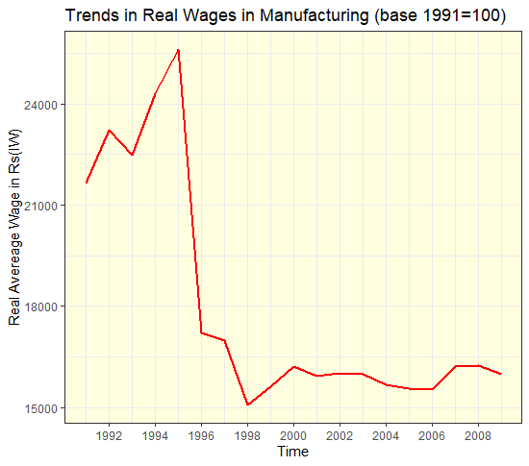

Fig1.1, Source: Handbook of statistics on Indian Economy, Tables 33 and 40(RBI,2012), Calculated from converting nominal wages to real wages using Consumer Price Index for Industrial Workers taking base as 1991.

In India there is a persistent lack of essential social and public services, we spend much less in education(2.8% vs 3.7% of GDP in by China, 2010-11), healthcare(1.2% vs 2.7% of GDP in by China, 2010-11) and have failed on the provision of basic necessities like clean water and sanitation systems like garbage disposal and drainage systems. We are much less behind on nutritional indicators than other countries who are behind us on economic growth but fares much better than us. Therefore it becomes even more important to look at the growth from a ‘characteristics’ perspective since ours is a democracy and by definition a democracy is supposed to serve each and every resident fairly, and equitably, if there is a huge gap in social indicators between sections of population then this implies shortcomings in the philosophy of the economic growth. It is necessary to have this understanding in a democracy setting since rectification in a democracy depends on public understanding and therefore to continue to have a shortsighted approach to growth in public reasoning would only lead to delay in making our government accountable and to equip us as individuals to make an informed decision. It is time that this notion of association of growth and GDP is foregone and we start looking at it from a wider lens encompassing dimensions of social equality, justice and development; it is only then can we truly become the India that championed the objectives of development and equity as it fought for independence and become one as was dreamt by the many leaders of the country.

References:

1 - Shekhar, A. S., & Zhutsi, J. Z. (2011). Portrait of Population. *https://censusindia.gov.in/nada/index.php/catalog/31512*.

2-Decennial Censuses from 1951-2011

3- Tao Yang et al. (2010)

4- Reserve Bank of India. (2012). *Handbook of statistics on Indian Economy, Tables 33 and 40*. https://rbi.org.in/Scripts/AnnualPublications.aspx